Students Achievements

- Students participated in Gour Gourav Utsav (26-28 April)
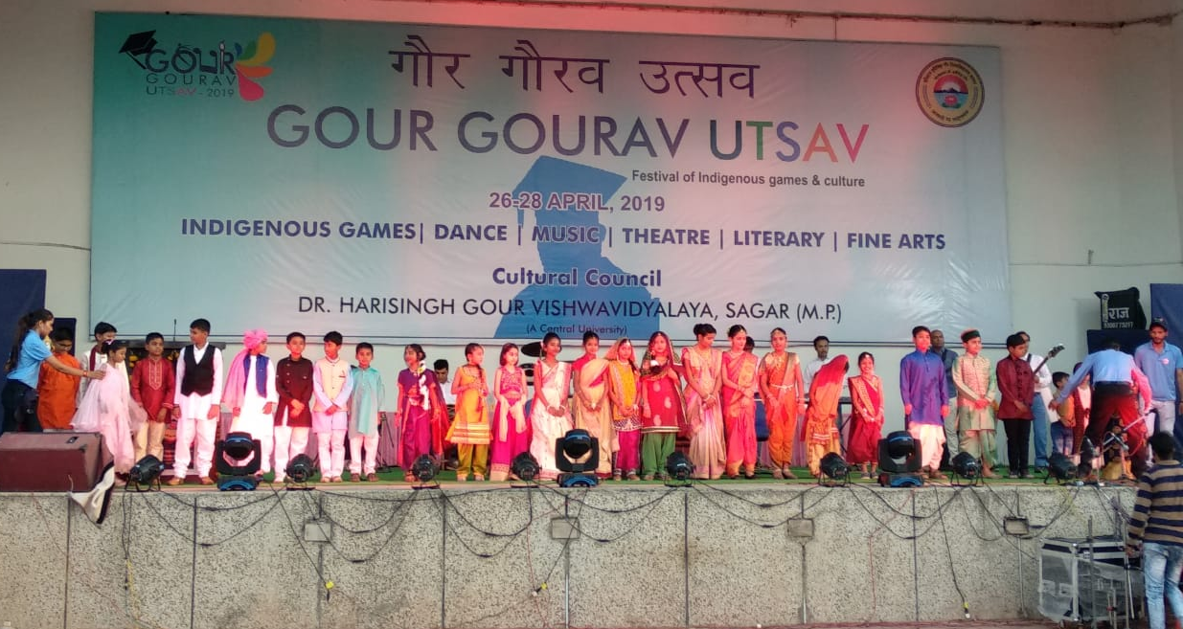

- Sahastranshu of class VI got First prize in singing competition
10th Annual Inspiration Dance Academy Award , Nobal College Sagar
